Top-down adventure/action game research:

List of top-down games:

* Hades
* Legend of Zelda: A link to the past
* Legend of Zelda: link between worlds
* Binding of Issac
* Hotline Miami
* Baldur’s gate 3
* Tunic
* Metal Gear
* Final Fantasy
* Fire Emblem
* Chrono trigger

Mechanics that are commonly used/shared:

* An attack mechanic is a definite mechanic that is needed, but depending on the genre, it can be used/done differently. E.g., like in Zelda, you just swing your sword when you press the button, in Final fantasy you can pick what attack is done in a menu and in Hades you have different kinds of attacks.
* A simple moving/running mechanic is another that is used in some top-down games. It’s used to move around the world but there could also be a running/deashing mechanic that blends into it. E.g., in metal gear you just run around, in Zelda you have a dash button, and in Hades you have a dash to dodge attacks. However, in some games like Final Fantasy and Fire Emblem the use of a dash or run is replaced with a probability when in battle, like the probability of an attacking hitting the character or missing.
* A mechanic to lift or grab objects like blocks or items is a mechanic that is used in a few games that can help with either fighting enemies or moving around the world or even to solve puzzles. Zelda does this a lot with how players can pick up pots and throw them in chance it breaks and gives them rupees, or to move a block to help them solve a puzzle.

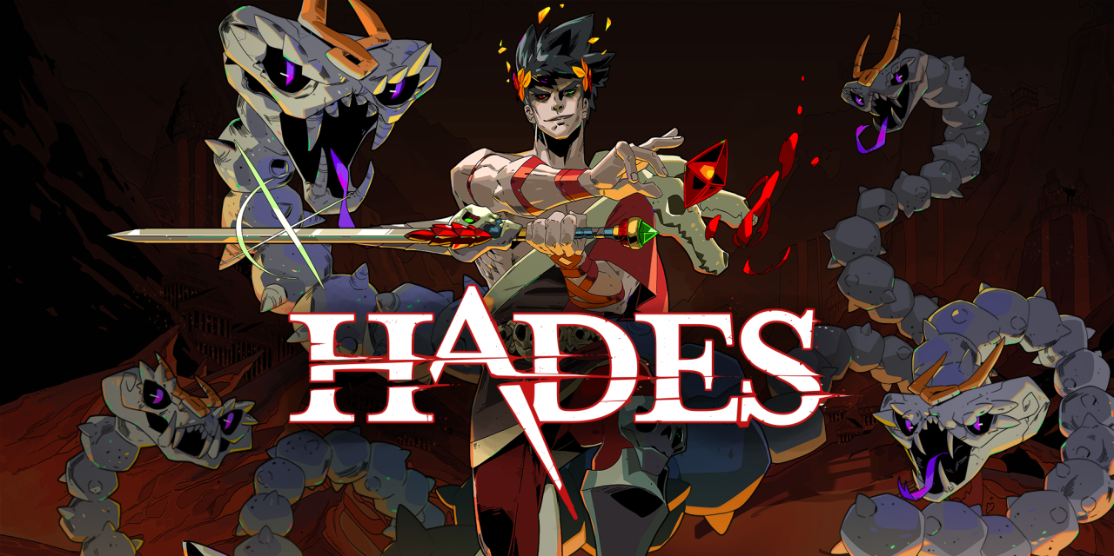

Hades:

Hades has a lot of different mechanics that make the top-down adventure game fun. You play as Zagreus, son of hades, and fight through the different areas of hell to try escape to the surface. Each realm will have a few levels/dungeons before coming up to the boss of that realm and having to defeat them to move on. When the player reaches the surface or dies, they sent back to the very start to try again but keep the rewards they got to upgrade and make themselves stronger to try again. The dungeons/areas are randomised each attempt, making it so you the player must be flexible to deal with different kinds of layouts and enemies. The player can change what equipment they have. They can have a charm given to them from making relationships/bonds with characters which help them and can choose between 6 different kinds of weapons. As they also make their way through their escape attempt, they can gain powers/abilities from the gods to help them (Zeus can shock/stun enemies, Poseidon can knockback enemies, Dionysus will poison enemies and so on). It provides a lot of random encounters, so no two escape attempts will ever be the same as the player could see a different enemy, have the aid of a different god, use a different weapon, and so on.

* Different weapons
* Status effects
* Randomizer
* Level hazards/obstacles
* Trial and error

<https://www.youtube.com/watch?v=4O9OjywwM1I>

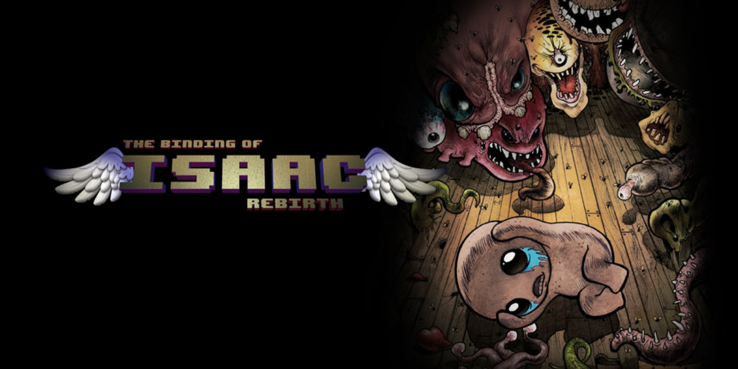

Binding of Issac:

The binding of Isaac is a dungeon crawler where player must explore the randomly generate dungeons and fight monsters using the characters tears as bullets or with items, they find around the dungeons which can increase health or strength. Player’s progress through the levels as they progressively get harder and must fight a boss at the end of an able to progress to the next one. If the player dies, they must start again from permadeath in a freshly generated dungeon, so no two runs will be the same. The player can collect coins to use in shops they find and able to play as different characters which have their own attributes when playing through the dungeons.

* Random dungeon/areas
* Items/ power up to aid player
* Shop sections
* Different characters/abilities

<https://www.youtube.com/watch?v=EkHQn_D0exQ>

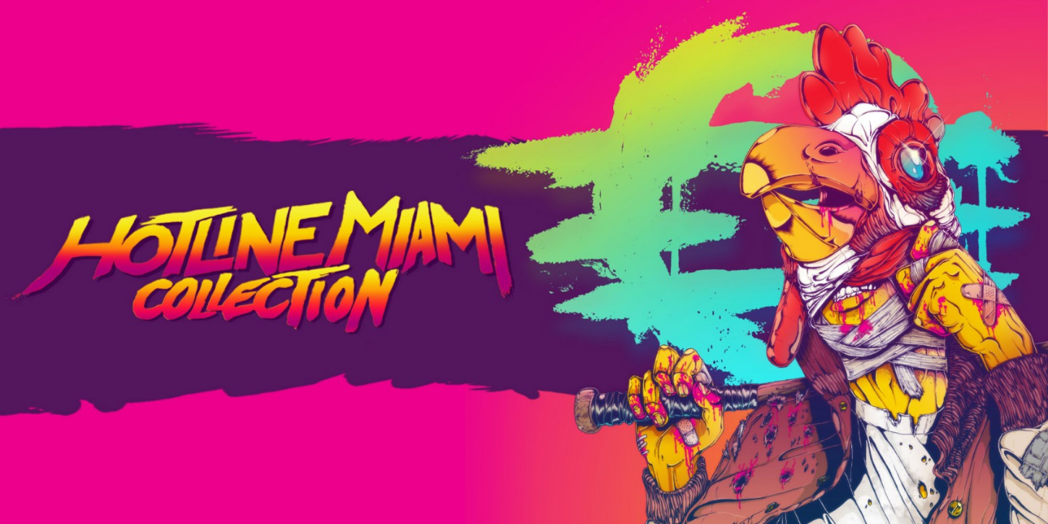

Hotline Miami:

Hotline Miami is a game where players go through different areas/levels and are tasked to kill all enemies and/or find key items before progressing to a boss to go to the next level. The player collects weapon off the enemies they kill or find along the way. Getting shot or hit once could kill the player so they must be cautious on how they approach with stealth or brute force. As they progress there are different kinds of enemies to deal with and different areas for them to adapt to and work around. As the player dies, they can restart the stage and try again and the game grades the player's performance based on factors such as speed, variation, and recklessness. Depending on how well they do, they can unlock new weapons or masks for them to use.

* Enemy types
* Layout/strategy
* Score/grade
* Interactive weapons

<https://www.youtube.com/watch?v=2n_BinoS1Ug>